土地利用計画と都市交通計画
Land Use & Urban Transport Planning
Hirohide KONAMI
1. Foreword
Land use plan and urban transport plan are very closely related functions each other. Land use cannot be realized without transport service and passengers never originated without some land use. We say “Hen and Egg. Which appeared at first?” Meaning is that both should be appeared almost at the same time.
Actuary, if there is no transport service, no land use comes out. Therefore, some original transport service is essential for the region. Then transport service should grow together with the development of land use. So said “Master Plan” is showing the final pattern of the development of the region but not the program of each year.
Another point would be the difference between existing urban area and the new development area. In the former case, we can examine the existing problems carefully and propose some new ideas to solve the problems such as the construction of new roads and subways. In the latter case, we carefully forecast the future transport demand based on the land use plan and propose the needed transport facilities.
From the view point of land use, the biggest transport demand will come out from the central business district, then shopping area, high raised apartment area, industrial area and residential area will follow.
Therefore, transport planning will be greatly influenced by the zoning system.

2. Japanese Zoning System
Following is the web information of PLAZA HOMES, LTD. in the next address and amended by the author a little.
http://www.realestate-tokyo.com/news/land-use-zones-in-japan/
Land Use Zones in Japan can be generally categorized into residential, commercial and industrial uses, and there are 12 zone categories in Japan.

Residential Use
1) Exclusively low-rise residential zone Category Ⅰ
This zone is designated for flat houses and 2 or 3 storied houses including attached small shops or offices and elementary and junior high school buildings.
2) Exclusively low-rise residential zone Category Ⅱ
In addition to Category I, certain types of shop buildings with a floor area of up to 150m2 are permitted.
3) Mid/high-rise oriented residential zone Category Ⅰ
This zone is designated for medium and tall residential buildings. In addition to hospital and university buildings, certain types of shop buildings with a floor area of up to 500m2 are permitted.
4) Mid/high-rise oriented residential zone Category Ⅱ
In addition to Category II, certain shops and office buildings with a floor area of up to 1,500m2 to provide conveniences for the local community are permitted.
5) Residential zone Category Ⅰ
This zone is designated to protect the residential environment. The permitted buildings include shops, offices and hotel buildings with a floor area of up to 3,000m2.
6) Residential zone Category Ⅱ
This zone is designated to mainly protect the residential environment. The permitted buildings include shops up to 10,000m2, offices and hotel buildings as well as buildings with karaoke box or small factory.
7) Quasi-residential zone.
This zone is designated to allow the introduction of vehicle-related facilities along roads while protecting the residential environment in harmony with such facilities.

Commercial Use
8) Neighborhood commercial zone
This zone is designated to provide daily shopping facilities for the neighborhood residents with the medium height buildings. In addition to residential and shop buildings, small factory buildings are permitted.
9) Commercial zone.
High raised banks, cinemas, restaurants and department stores are constructed in this zone. Residential buildings and small factory buildings are also permitted.

Industrial Use
10) Quasi-industrial zone
This zone is mainly occupied by light industrial facilities and service facilities. Almost all types of factories are permitted except those which are considered to considerably worsen the environment.
11) Industrial zone.
Any type of factory can be built in this zone. While residential and shop buildings can be constructed, school, hospital and hotel buildings are not permitted.
12) Exclusively industrial zone.
This zone is designated for factory, office and administrative buildings. Residential, shop, school, hospital and hotel buildings cannot be constructed.

Each Zoning is managed with floor volume, the maximum height of building and floor usage restrictions under the provision of the Building Standard Law.

In case of new development, these regulations can be strictly applied but in the old existing urban area, these regulations are not applied for each building until the owner wants to rebuild.

3. What is the difference between land use plan and zoning?
Zoning could be said to be the detail plan of land use. More precise plan would be the district plan under the City Planning Law and the Building Standard Law.
Land use plan is just showing the future direction of land use as a reference, and zoning is the legal rule to realize the land use plan. District plan is a tool to decide the more detail such as the shape, color, material and the limited usage of the building and sometimes decide the exception of the zoning.
The level of precision of transport planning is not so precise as zoning but we need the location map of business and shopping areas, industrial areas and residential areas.

4. Land use and transport demand
As I mentioned before, land use and transport demand are very closely related, and those two should be carefully planned at the same time. But in Japan, bureaucracy interferes the close relation of both sides and there happens so heavy traffic jams and congestions.
Master plan will show the completed future urban figure. On the other hand, actual urban development projects would advance year by year. If we construct the all of the transport facilities just like in the master plan, it would be accused to be over investment. Then transport plan should match to the master plan of land use but the actual construction work should be the staged construction program, in other words, the construction work should be planned year by year based on the speed of the land use realization. In the strict sense, zoning and some district plan should be followed by the transport assessment. Assessment should be performed as follows.
1) Decision of the assessment area:
Zoning area or district planning area will be the assessment area.
2) Estimation of the future urban functions in the area by traffic zones:
This will become the basic data of transport demand. We should decide the traffic zones at first. Address zone or some statistical zone would be taken into consideration. Then total floor area by usage, number of the workers, number of the residents, number of the car ownership, and the other statistical figures such as industrial production and wholesale and retail amount should be estimated by each traffic zone. If mesh-data is available, traffic zone can be replaced by the mesh.
3) Estimation of transport demand
Each urban function will have the data of traffic origination by floor area or land area and we will get the total traffic origination of each traffic zone by traffic purposes. Then, transport planning technique such as traffic distribution model, traffic assignment for each traffic mode, and traffic assignment for each traffic link will be applied for each traffic demand by purposes.
We can introduce the present pattern model in case of existing urban area and gravity model in case of new development to estimate the traffic distribution.
Assignment for each traffic mode is a part of the planning. Because if there were more convenient and cheap transport service, the passengers would be easily influenced to choose such transport service. Then we need the service level of each transport mode among the traffic zones. In this case, traffic purpose will have the great influence on the modal choice. For example, commuting is OK by public transport but shopping may be more convenient by private car. Family leisure traffic may also choose the private car.
Of course these are influenced by the car ownership and the service level of public transport. These factors also change year by year.
As transport planning is so complicated and the same area will never exist, so it is necessary to make up the project team consisted by land us planners and transport planners leaded by experienced city planners.

5. Land Use Planning
Land use planning is expressed on the map by colors such as brown for business district, red for commercial area, orange color for high density residential area, yellow for low density residential area, blue for manufacturing area, green for forest and parks, and light green for agricultural field. In drawing the land use map, it is necessary to take into consideration the following matters.
1) Geological conditions such as plane, hill, river, mountain, lake, and so on.
2) Distribution of existing urban functions
3) Land demand for each usage based on the future population and industries
4) Existing transport facilities and their present condition and capacity
5) Proposed future transport facilities and their capacity and service level
6) Mutual relation of each land use such as residential area should be near from commercial and business area as much as possible and apart from the noisy industrial area or heavy traffic zones.
7) Choice of the suitable urban pattern if necessary such as leaner type, ring and radial type, or grid type, or their combination.
8) The influence of new commercial areas on the existing commercial areas
9) Record of disasters
10) History and cultural properties of the area

The easiest way to draw the land use planning map will be to imitate the similar advanced city. In this case, it is necessary to compare the population size, geographical condition, development level of economy and the history. Then introduce the good points and improve the bad points.

6. Transport Planning
6-1 General information
Before starting the planning, we need some general information as follows.
1) Geographical conditions such as river, lake, mountain, hill, height from sea level, and so on.
2) Capacity and service level of existing transport facilities such as road, railroad, port, airport, and so on.
3) Record of disasters
4) Record of traffic accidents
5) Proposed future land use

6-2 Present transport demand survey
There are four types of survey method. One is person trip survey by the questionnaire for 3 to 10 % sampled people of the area asking the trips they made in a certain day, departed place and time, purpose, traffic mode and route, and arrived place and time. Second is the questionnaire for car owners asking the trips they made in a certain day by car, departed place and time, purpose, route and arrived place and time. Third is the data from automatic traffic counters along the roadside. This can be performed by research persons standing on roadside with traffic counters. Fourth is the questionnaire for transport establishment such as railway company, truck transport company, bus and taxi company, and air and ship transport company. In this case we can get the data of not only passengers movement but also freight movement.
Based on these surveys we will get the present transport demand together with the problems and conditions.

6-3 Present transport facility and traffic condition survey
Existing transport facilities such as road, street car, railway, port and airport should be printed on the maps of the scale 1/10,000 or around. Present usage of those facilities should be carefully analyzed by the transport planning engineer.

6-4 Future estimation of transport demand
Based on the above mentioned traffic data and land use plan, future transport demand will be estimated as mentioned in 4. 3).

6-5. Final stage of transport planning
Transport planning engineer team will draw the transport planning map based on the above mentioned various data. They will consider the way of traffic service for each traffic demand by purposes. Those are commuters, business traffic, freight traffic, shoppers, leisure traffic and so on. Traffic modes such as walking, bicycle, motor cycle, passenger car, truck, bus, streetcar, light rail, heavy rail, subway, ships and airplane. Also transport facility has the suitable service level or type of the facility for each traffic demand and purpose. For example, pedestrian road for comfortable walking, elevated highway for heavy traffic, exclusive bicycle road for leisure, and heavy rail for commuters.
These planning is so much complicated and need the experienced engineers and planners. In old days without the electronic computers, an experienced planner could draw the planning map by his intuition, but in these days, we need to analyze the data and prepare the understandable explanation for the planning. This is already beyond the personal capability and we need a good team work for the planning.

7. Conclusion
Land use and transport planning is the base of urban development but too much complicated and the imitation of advanced city would be the most recommended way for the first study. New development and the development existing urban area are quite different because there are many existing conditions and problems in the latter case.
It is also important to understand the necessity and the target of the study imaging the final goal of the planning.
Basic data are quite different from country to country. For example, population density in Japanese urban area has the density of 40 people per hector or more and over 150 people per hector in big cities like Tokyo and Osaka. But this is quite different in Fenway Park in Boston, Massachusetts, USA. The population density over there was around 20 people per hector even it was four or five storied apartment area. This was caused by the area of public space such as roads and green parks and the spacious rooms on each floor. Japanese living room is at most 20-30 square meters but, in Boston, it is double or triple size. Like this we should understand the historical, cultural, and physical difference of each country.

8. Appendix I: Way of planning of one million new town
1) One million city requires usually 200～300 km2, 15 km each side if it is square. Such area should be carefully selected on the geographic map excluding the disastrous area such as land sliding, land sinking, water flood and historical heritage or the other valuable areas.
2) One million city requires at least two heavy railway lines, elevated or underground. Then draw the two lines carefully based on the location of flat land where town centers should be developed.
3) One million city should have one or two trunk roads with the width of 50 to 100m. Then draw the two trunk roads on the map usually in parallel to the railways with a little interval.
4) Put the location of main urban functions such as railway stations, city hall, central business center, sub business centers, shopping centers, high level educational functions, industrial areas and green parks on the map taking the location of railways and trunk roads into the consideration
5) Plan the zoning, especially the location of high raised residential areas and flat residential areas, and city planning roads based on the traffic demand estimation.
6) Plan the other urban functions such as hospitals, fire stations, police stations, primary schools, high schools, neighborhood parks and the other necessary urban functions.
7) Plan the management of life lines such as water supply, electricity, urban gas, internet, waste treatment and water sewage system.
8) Plan the urban management such as construction program by year and year, introduction program of public transport including rail, bus and taxi.
9) Finally check the plan from the view point of finance.

9. Appendix II: Transport Planning Manual for Big Size Development Project
Mainly from the HP of MLIT, http://www.mlit.go.jp/common/001042950.pdf
1) Project size
This manual intends to apply for the development size shown below.
Shopping floor | Floor area equal or over 10,000㎡
Bussiness floor | Floor area equal or over 20,000㎡
Residence, hote and Mixed use | Considered to be equivalent as above
2) Estimation factors
Following factors should be estimated.
Commuters’ automobile traffic | Depends on the service level of public transport
Visitors’ automobile traffic | Same as above but for short time
Business automobile traffic | Depends on the business type
Two wheel vehicle traffic | Influenced by the social development level
Parking demand | Dpends on the automobile traffic
Goods transport | Dependa on the floor usage
Taxi demand | Depends on the number of visitors
Pedestrian on street traffic | Depands on the location
Pedestrian exclusive zone traffic | Depends on the area design
Rail and tram traffic | Depends on the public transport
Bus traffic | Depends on the bus service
3) Estimation of person trips
Number of person trip ends per hector, per day is as follows.
Business floor | From 2,200 in local area to 4,300 in metropolitan area
Shopping floor | From 10,600 in local area to 21,800 in metropolitan area on holiday
Residence | 700 per ha or 7 per household
Hotel | 1,300 ±600

4) Estimation of traffic distribution
This should be based on the existing person trip suevey and aoutomobile OD survey. Usually present pattern method or gravity model would be useful for this estimation.

5) Estimation of traffic mode and volume
This is completely different by each district and needs the analysis of specialists.

6) Estaimation of peak hour traffic demand
This is the basic data for the transport planning and needs the help of transport specialists.

7) Facility planning or feedback to the development plan
If the facility planning said imposible, development plan should be reviewed again.

10. Appendix III: Profile of the lecturer
Dr. Hirohide Konami was born in 1942 in Tokyo, graduated from the University of Tokyo, Facalty of Urban Engineering in 1966, studied at GSD, Harvard University. After worked for tha national government for 31 years, got the professorial positions in the University of the Philippines, Toyo Univesity in Tokyo, Tokyo Jogakkan College and the Teikyo Heisei University for 17 years. Present job is the Exective Director of the Research Institute of National Land Policy. Through all these positions, experienced in landuse planning, comprehensive transport planning, enviroment assessment, land readjustment project, newtown development and urban renewal not only in Japan but also in the Philippines, Indonesia, Thailand, Egypt, Yemmen and Boston, Massachusetts.
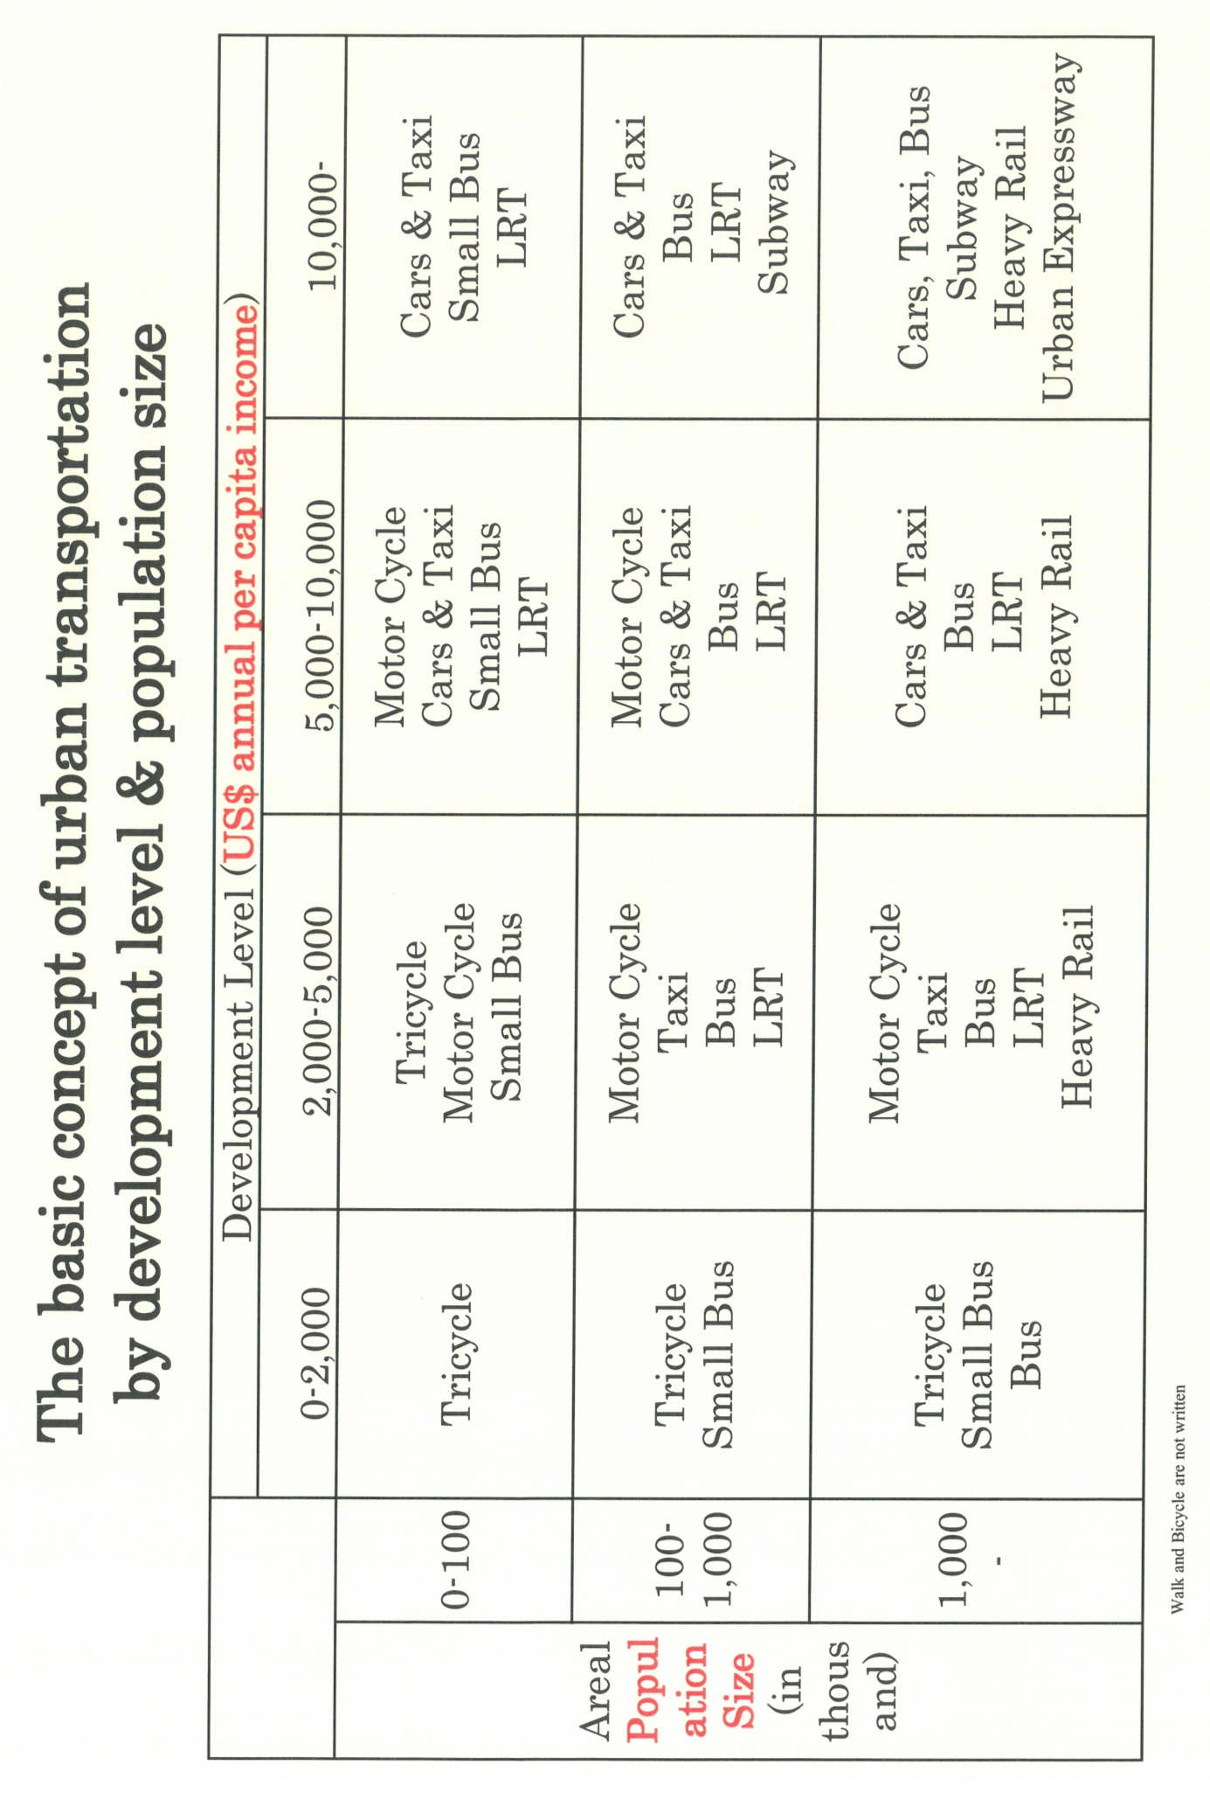
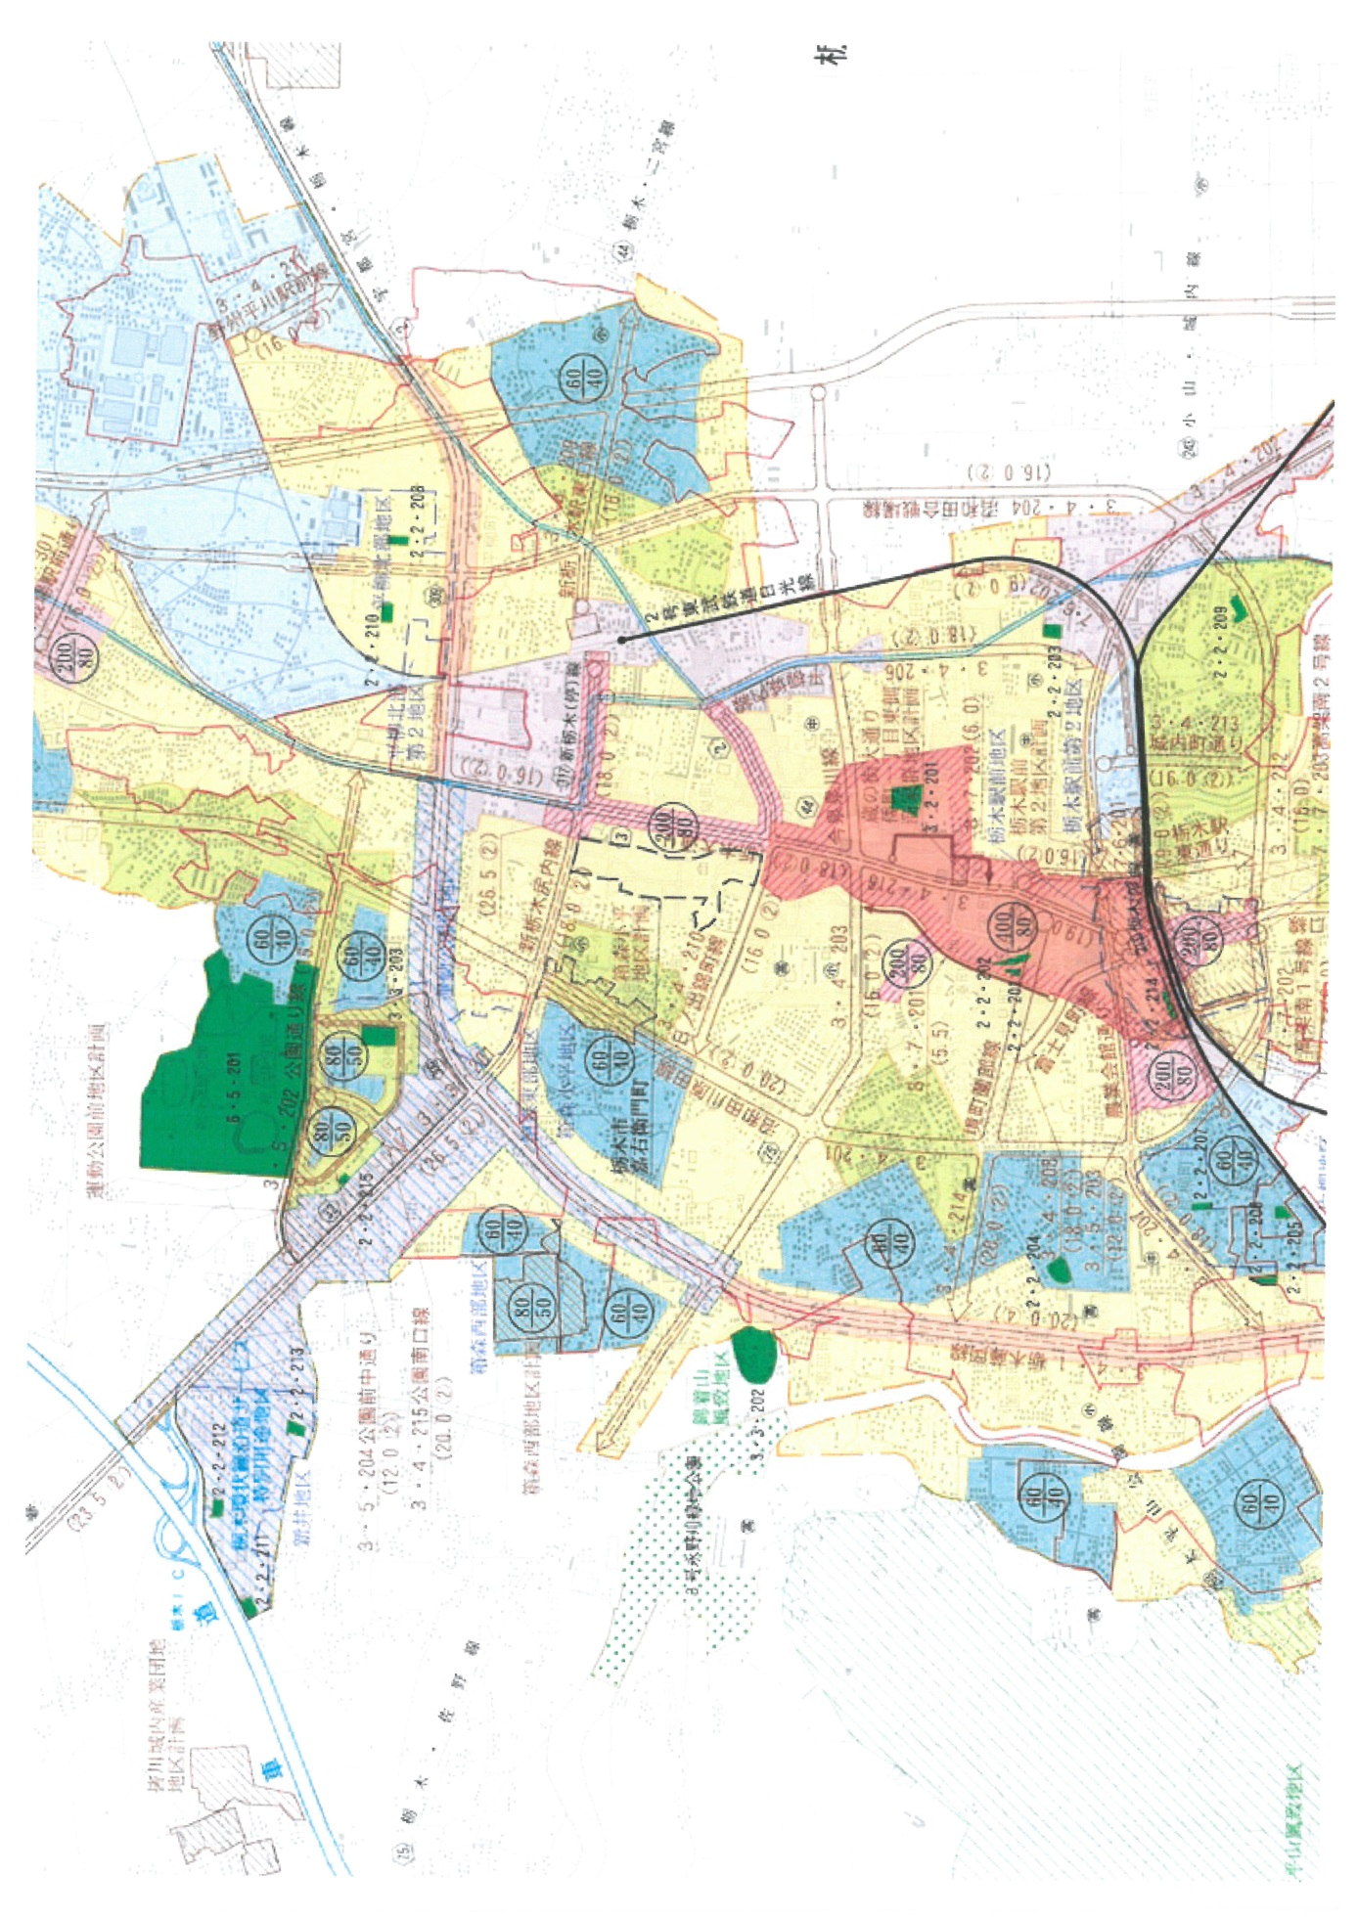
Tochigi City is located 80km north of Tokyo with the population of about 200 thousand. Land use and transport plan is very well prepared.

