EAROPH world congress 2014 in Jakarta
Three Year Experience of Restoration in Japan
After the Huge Tsunami Disaster
by Hirohide KONAMI
(Mr.&Dr., EAROPH Lifetime Member)

Three years have passed since the huge Tsunami Disaster on March 11, 2011. Including the refugees from the radioactive area around the nuclear power plants, the number of refugees has decreased to 274 thousand from the peak of 470 thousand right after the disaster. 274 thousand refugees are still living in public supplied temporary houses and apartments or living together with their relatives. The decrease rate of the population in the Tsunami suffered areas would be about 10%. We are not sure whether or not they return to their hometowns after the completion of reconstruction projects.
This paper shows the efforts of the governments and people in these three years such as highway reconstruction, urban redevelopment, land readjustment, restoration of land subsidence, construction of restoration center including refuge tower, purchase of suffered land, deduction of loan for the suffered people, finance for the suffered enterprises, and so on.

The heap of rubble and debris
The disaster left the huge amount of rubble and debris such as 27 million ton. These were mainly burned by countrywide incinerators and almost finished by this time. It took three and a half years. There were some refusal saying that those debris might have radio effects but there was no such fear because of the strict check at the original areas.

Population
The outflow of population is about 6 or 7% at the seaside areas. The population migration has become almost the same as before the disaster.

Infra Structures
Road, railway, port facilities, water supply, water treatment are almost reconstructed and fishery port, agricultural land, new residential areas are still half or under half.
54 Nuclear Power Plants in Japan are still all stopped the operation and electricity supply in Japan is unstable. We have no blackout yet but the electricity charge is going up year by year. Japan is paying nearly 30 billion USD additionally every year to the oil production countries.

Radioactivity
Northwest areas in the distance of within 30 km from atomic power plant are still prohibited to live. The other areas are gradually recovering from radioactivity by elimination works and safety announcement have been done.

Recommendations
Radioactivity in 2013
1. Huge tsunami in Japan reached the height of 20 or 30
meters and the quick evacuation is the most important.
Residential areas in high land would be hopeful but such
people as fishermen will prefer to live portside low land.
20km
Then some evacuation towers or tall apartments are needed
and some construction works have been started in several areas. Evacuation distance should be within 500 meters.
Be Careful Danger
Safe

2. The urban reconstruction technique should be carefully chosen case by case and Land Readjustment is the most recommendable. In case of big disaster, many land owners and stakeholders would be missed and Japanese Land Readjustment Law is well prepared for those cases. Problem was the lack of experienced technicians in local governments and so many officials in big cities and Urban Renaissance Corporation have been dispatched to the suffered cities and towns. Then it is recommended for local governments to continue some land readjustment project, small one would be OK, and to keep the experienced technicians regularly.

3. Exercise to evacuate and rescue is very important. In case of Tohno City, the prefecture wide exercise had been done twice just before the disaster and rescue troops of police, fire station, self-defense army could make actions very quickly. In case of Kamaishi Elementary School, pupils were very well trained and no victims found. On the other hand, in case of Ohkawa Elementary School in Ishinomaki City, teachers spent 40 minutes to discuss and decided the evacuation place so lately. Such delay caused the victims of 74 pupils out of 108 and 10 teachers out of 11.

4. This disaster caused blackout in wide areas and information system couldn't work well. NTT (Nippon Telephone and Telegram Company) supplied satellite phones to the municipalities, and only those several phones could work well in case of Tohno City.

5. Gasoline supply for automobile was terrible and many rescue works faced difficulty for one or two weeks. One reason was of course the damage of roads and bridges and the other reasons were the damages of oil production sites and gasoline stations.

6. Many oil tanks at the mouth of the harbour were fallen down by huge tsunami and caused big fires. Then some defense wall may be needed for those facilities.

Finally, it is difficult to decide. The next such big Tsunami would be several-hundred-years later and medium size Tsunami such as 5 meters or so would be every one hundred years. 250 billion USD budget is aiming to overcome such huge Tsunami even people may forget such big one during the long term of hundreds of years.

Bank Loan Exemption or Reduction Guideline for Suffered People
Japanese government prepared a special guideline to exempt or decrease the bank loan of suffered people. Those people who have lost their houses and cars are facing the difficulty such as the double loan. This means that they should repay the former loan and also shoulder the new loan to rebuild their houses and to buy a car. Therefore national government prepared the guideline to reduce their duties.
Applicant should be a private person and should prove that he had no delay for the regular repayment before the disaster. Then he can request the help of a lawyer temporary hired by the national government and submit the necessary documents to the Guideline Management Committee. If the committee agrees to the documents, the committee will recommend the exemption or reduction of the bank loan to the related banks or other finance institutes. Then banks or finance institutes will decide the exemption or reduction of the loan under the financial support of the national government.
After all, the suffered people will be able to rebuild their houses and buy a car under the new bank loan system with the especially low interest rate.
Rubble and Debris
Only Hotel remained in Miyako City. The other wooden houses were completely swept by Tsunami

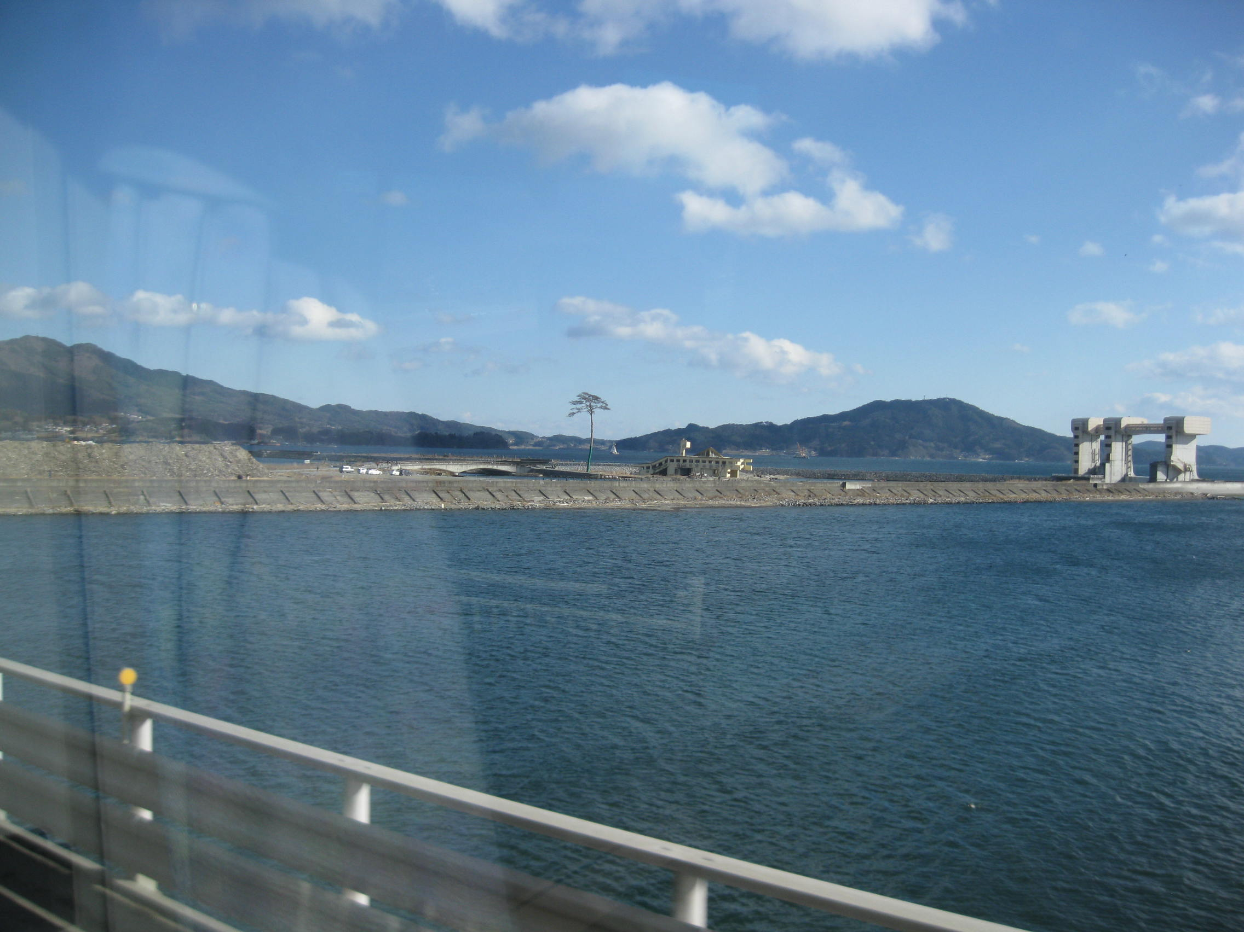
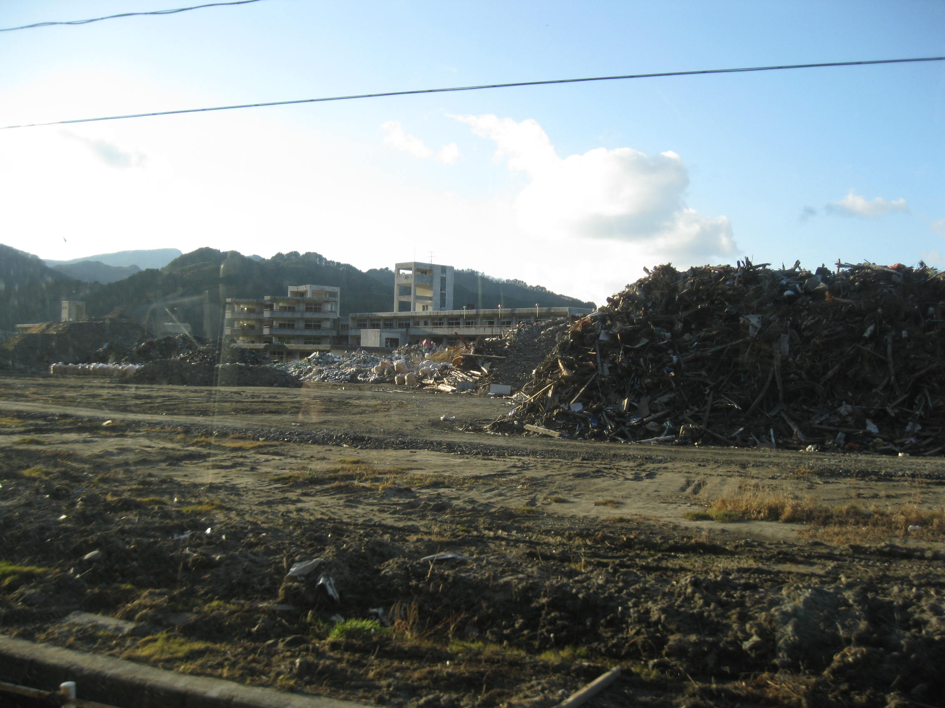
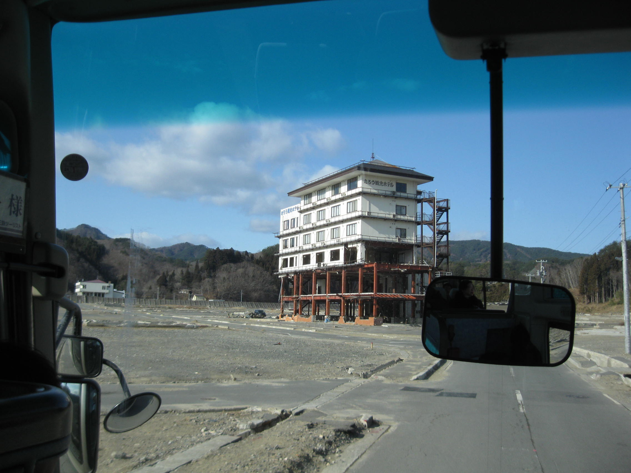
Only tree remained among the thousands of seaside tree band
Belt conveyer to carry the soil from hillside to sunken fields, UR
Press Vol.37, 2014
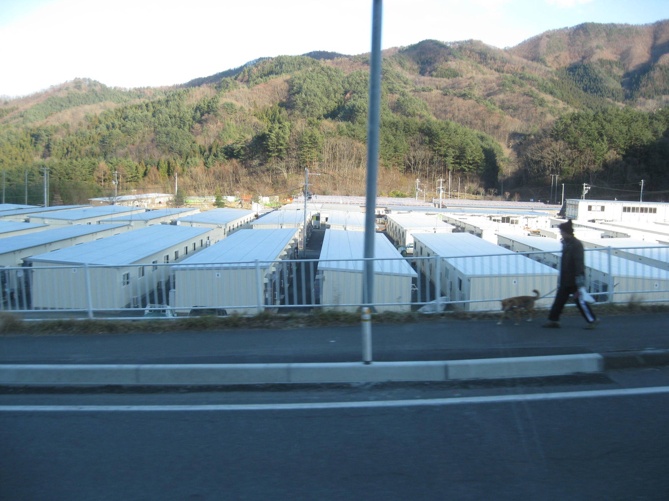
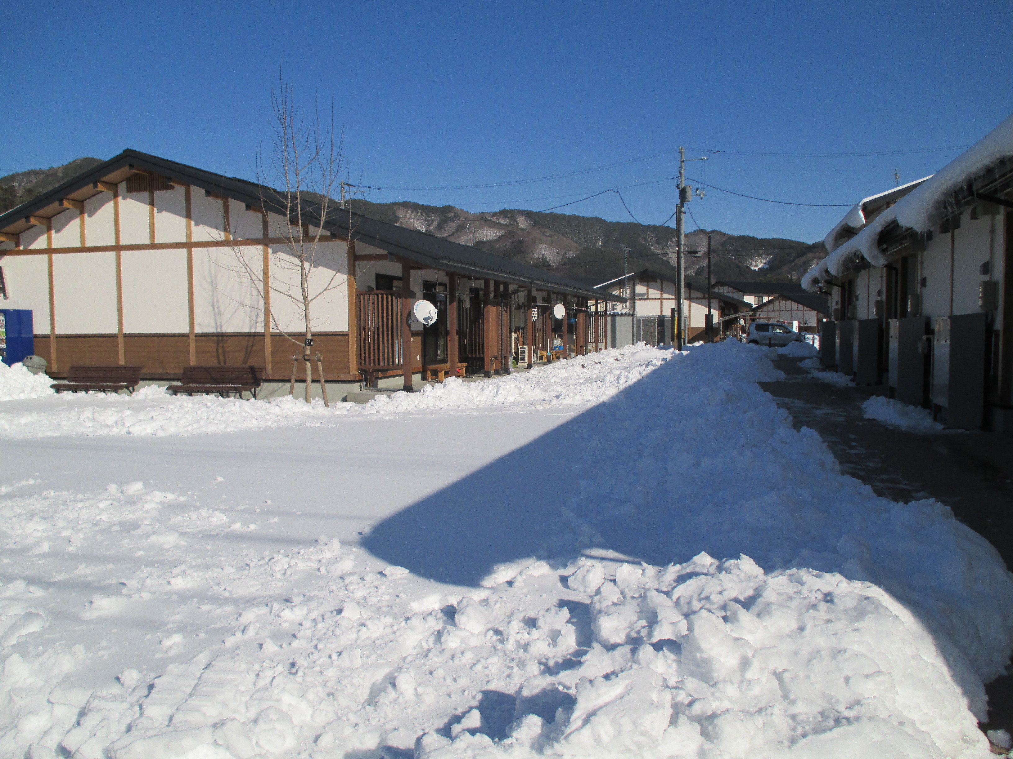
Modern public houses for the suffered people, 2014
Fefugee’s houses right after the disaster,
2011

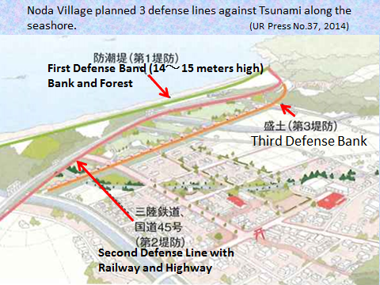
Noda Village planned 3 defense lines against Tsunami along the seashore. UR Press No.37, 2014

Presenter:
Hirohide Konami (Mr. & Dr.)
EAROPH life-time and executive committee member, graduated from the University of Tokyo, Urban Engineering Department in 1966, studies in the Graduate School of Design, Harvard University in 1971. He worked for the Japanese government for 31years. After the retirement he worked for 17 years as a professor of the University of the Philippines, Toyo University, Tokyo Jogakkan College and Teikyo Heisei University. Then he was assigned to the executive director of the Research Institute of National Land Policy, Japan.

