**The Basic Concept of Urban Transportation Planning**

Hirohide Konami (Mr. & Dr.)

Executive Director, The Research Institute of National Land Policy

Eastern Asia Society for Transportation Studies

World Congress at Sheraton Saigon Hotel & Towers in Ho Chi-Minh

2017.9.19

**Forewords**

The key factors of urban transportation planning would be as follows:

1) Urban size

2) Urban pattern and geographic condition

3) Level of economy development

4) Increase of aged or handicapped people

5) Risk of natural hazards

6) Level of affordable technology

7) Land acquisition system

Many years ago, such as 1960's and 70's, we were taught just 1), 2) and 3). We didn't have a consideration room for aged or handicapped people. We didn't recognize the so big natural hazards such as huge earthquake attacked Japan in 2011. We didn't have such advanced technology such as automatic driven vehicles and super high-speed trains. Land ownership is different from county to country. I will try to examine these matters one by one in this study.

**1. Urban Size, Urban pattern and Geographic condition**

Transportation demand differs by urban size and its pattern. The easiest way to understand this relation would be to review the past fact of other cities. Every village started from walking in ancient days and developed wider by means of shipping, horse or cow's carrier, two-wheel vehicle, railway, bus and automobile. Starting from a small village of the population of one hundred or one thousand supported only by walking, the area may grow to megacities such as Tokyo, New York, London, Paris, Beijing and Shanghai.

Table 1 shows the change of transportation mode from 1998 to 2008 in Tokyo metropolitan region, we may say Greater Tokyo, with the population of over 30 million.

Table 1 Transportation mode in Greater Tokyo (%)

|  |  |  |  |  |  |
| --- | --- | --- | --- | --- | --- |
| Year | Car | Rail | Bus | Two wheel | Walking |
| 1998 | 33 | 26 | 2 | 17 | 22 |
| 2008 | 29 | 29 | 3 | 16 | 21 |
| In transit case, one mode is selected by the priority order of rail, bus, car, two wheel and walking. | | | | | |



Fig. 1 Comparison of transportation mode in Central Tokyo and Greater Tokyo

Table 1 and Figure 1 tells us that the rail and bus transport began to replace the car transportation within these 10 years. This is the first experience for us, while we have been just considering the increase of automobile usage. There may be two reasons. One is the development of railway network and the second is the people’s change of getting age. Along with another experience that the total population of the country started to decrease in 2006, the Japanese government is trying to renovate the cities into compact and networking ones. This is a new aspect of transportation planning.

Then, population size is the most important factor to plan the transportation mode. Table 2 shows the basic concept of transportation mode by urban population size and the income level of the citizens.

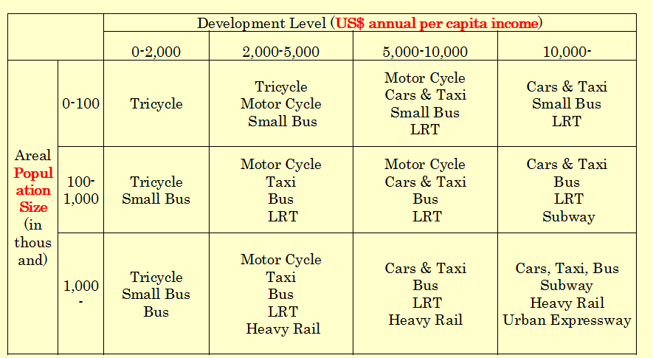

Table 2 Basic concept of transportation mode by population size and income level

Urban pattern and the geographic condition are also important to discuss the planning. There are leaner type, ring & radial type and wider band type. Normally urban area starts from the leaner type along the street and getting wider. Geographic condition will also influence on this pattern such as wide linear type in Kobe City, ring & radial type in Tokyo and other big cities. Kobe City has just 3 east-west railway lines connected with some feeder lines. Population size is about one million and half.

Greater Tokyo, over 30 million, has very densely developed railway network. They are 3 ring lines, Oedo, Yamanote and Musasino Lines, and 25 radial lines, Keikyu, Tokaido, Yokosuka, Keihin Tohoku South, Toyoko, Denentoshi, Odakyu, Keio, Chuo, Chuo-Sobu, Seibu Shinjuku, Seibu Ikebukuro, Tobu-tojo, Tohoku, Keihin Tohoku North, Tobu-nikko, Tsukuba Express, Joban Express, Joban Local, Keisei-narita, Keisei-main, Sobu Express, Sobu Local, Tozai and Keiyo Lines. There are 12 underground railway lines in the central area such as Ginza, Marunouchi, Hibiya, Tozai, Chiyoda, Hanzomon, Nanboku, Yurakucho, Fukutoshin, Toei-mita, Toei-asakusa and Toei-shinjuku Lines. To add to these there are short service of Inokashira, Ikegami, Oimachi, Nanbu, Yokohama, Tamagawa, Shinkeisei, Tobu-Noda and Rinkai Lines, Haneda monorail, Yurikamome and Nippori-Toneri Liner LRT.

We must carefully estimate the above mentioned matters about the study area and decide the mode, location and capacity of trunk lines. Then feeder lines should be added in line with the urban growth.

**2. Level of Economy Development**

The level of economy development gives the great influence on the transport planning by both ways. One is the investment and maintenance power and another is the capability of fare payment of passengers.

Investment power consists of governmental money and private investment expecting the return from the fare and development benefit around the stations. Capability of fare payment depends on the income level of passengers and the share system of each company for commuting cost. Private railway company can expect the development benefit by means of land area development around the stations if they can purchase the cheap land before the train construction.

In order to promote the public transport usage, governmental subsidies for the construction cost and partially management cost is essential. Then fare could be kept cheap and usage of rail and bus will be promoted.

It is also important to consider the speed of the urban growth. We experienced many problems as follows:

1) Because of the delay of infrastructure development, poor service of railway and bus caused unexpected congestions in peak hours and passengers should have kept waiting for a long time or packed like materials in the carrier.

2) The lack of road capacity caused the flood of two wheel vehicles and cars and people face the unendurable traffic jams followed by the severe air pollution.

The study of “Traffic Demand Management” started last century in Singapore but the fruitful result hasn’t been found. Railway and urban expressway construction seems to be the only good solution.

**3. Increase of Aged or Handicapped People**

The share of aged and handicapped people was not so big problem before. But in these days, this became a big topic because the aged people cannot drive and isolated and lonesome aged people have been increasing in Japan. This will happen in almost all countries in the world in the near future.

Then some suitable bus service for them to go to railway stations, hospitals, shopping centers and other needed facilities became necessary. Therefore, the estimation of the increase of those people became more important in these days. The share of the people over 65 in Tokyo is about 1/4 and almost half in rural areas. Aged people over 70 in Tokyo can buy one-year bus and Toei-rail ticket by only 1000 yen, about 10 US Dollars. This is good not only for saving money but also to promote them to go out from home.

**4. Risk of Natural Hazards**

The risk of natural hazards is becoming more important in Japan in these days because we experienced so a big earthquake and Tsunami in 2011 and also facing the unexpected heavy rainfall caused by the climate change. Transport system is the most important system to keep and rehabilitate the life in those areas. Therefore, double link or triple link of transportation system, hopefully by different modes, are expected in main routes.

**5. Level of Affordable Technology**

The consideration for affordable technology is very important especially in the under developing stage. Speed, comfortableness, safety and difficulty in construction should be carefully examined.

For example, railway construction in Japan has been changed like this. Starting from the construction on the ground, then on the mounted bank, then elevated bridge, then underground and deep underground. Japanese law says that the construction of public facilities in densely developed area can be recognized to use deep underground by the permission of the MLIT Minister or the Prefectural Governor with the reasonable compensation.

In such way, affordable technology changes by the level of economy of the region. Planner should carefully propose the suitable technologies.

**6. Land Acquisition System**

Land acquisition or land ownership system is also important factor to plan the transportation facilities. In Japan, land ownership is very strong and the land acquisition cost is increasing. Then transportation planner should learn enough about those factors in advance. Land Readjustment Project works very well in Japan in both case, highway construction and railway construction.

**7. Conclusion**

Transportation planning is facing the difficulty in both areas, developed areas and under developing areas. The most important matter in developed areas is how to control the car usage. And that of under developing areas is how to construct roads and railways. The second important matter in developed areas would be how to maintain the transport facilities under the circumstances of the decrease of population and passengers, and that of under developing areas would be how to keep the harmony between transport and land use. The third important matter for both region would be the air pollution and accidents.

Transport planner’s responsibility is getting more important than before because the share of contribution of CO2 output from automobile is so big and the global climate change is now critical stage.

It is also important that how we can introduce new technologies such as electric car, extra high speed train, automatic driven car, Segway, and so on.

We cannot forget the importance of shipping, air transport, cable car (ropeway), conveyer and elevator.

Transport planners should study not only traditional subjects such as traffic generation, traffic distribution and traffic assignment but also geography, economy, technology and urbanization mechanism.

**References:**

1) Person trip survey reports and freight movement survey reports of Ministry of Land, Infrastructure and Transport

2) “Urban Transportation Policy”, Text of JICA training course “Comprehensive Urban Planning”, Hirohide Konami, 2016

**Author: Hirohide Konami (Mr. & Dr.)**

Born in 1942 in Tokyo, Japan. After graduated from the University of Tokyo, Faculty of Urban Engineering in 1966, studied at the Graduate School of Design, Harvard University in 1971-72, and worked for the national government for 31 years. After retirement from the government, experienced the professors in the University of the Philippines, Toyo University, Tokyo Jogakkan College and Teikyo Heisei University for 17 years. Then assigned to the present position in 2012.

